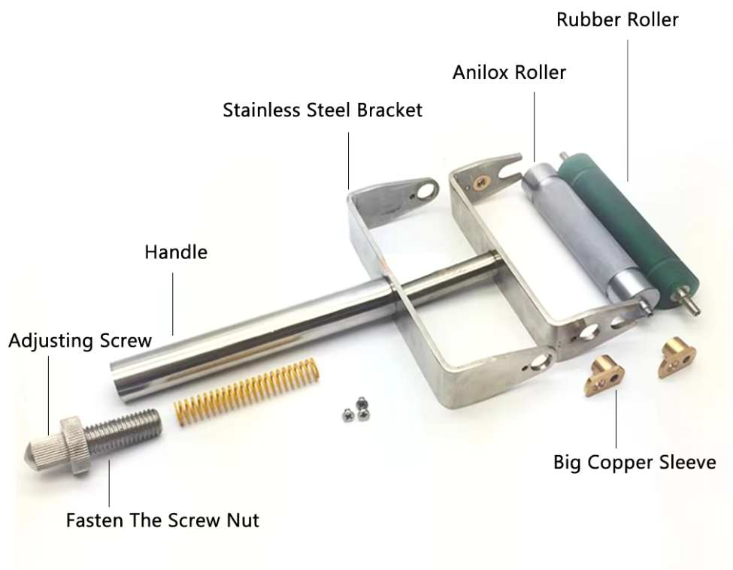
Ink Proofer (Ink Sampler) User Manual

I. Introduction: This instrument is specifically designed for flexographic ink color matching and proofing, and is widely used in ink production, carton printing, flexographic printing, and other industries. Its novel design and unique structure, composed of stainless steel and a metal anilox roller, allow it to produce reproducible color samples on various substrates using water-based inks, gravure inks, aniline inks, or other liquid coatings. It simulates the printing effect of a printing press and is an essential tool for color matching, ink mixing, testing the printing performance and color depth of water-based inks. It is also an essential tool for printing plants to test spot colors.
II. Usage: Loosen the locking nut. Adjust the nut rod to the appropriate position according to the viscosity of the ink used, so that there is appropriate pressure between the rubber roller and the metal anilox roller. Tighten the locking nut to control the ink layer thickness. The greater the pressure, the thinner the ink layer. Use the ink applicator to place a small amount of ink between the rubber roller and the anilox roller. Place the substrate (such as paper) on a level, smooth surface.
Hold the handle of the spreading wheel so that the rubber roller at the front of the spreading wheel contacts the substrate, ensuring the spreading wheel is at approximately a 30-45 degree angle to the table. Pull the handle back to create a color ribbon.
After use, loosen the locking nut and turn the screw counterclockwise to disengage the rubber roller from the anilox roller.
Clean the spreading wheel thoroughly and return it to the box.
III. Precautions: The ink proofing machine (manual spreading wheel) is a precision instrument. Take special care to protect the rubber roller and metal anilox roller, and avoid contact with hard objects. Clean thoroughly after use. If not used for an extended period, apply anti-rust oil to the surface of the anilox roller to prevent rusting.

Hangzhou ZHIYI Technology Co., Ltd
Website: www.iqctest.com
What’s app/we chat: +86 13336040868

